Reminiscence of Parkinson's Disease in Functional Connectivity of Healthy Individuals with Bad Quality Sleep

Sebastiano Vacca1,2, Joan Falcó-Roget3, Alberto Cacciola4, David Eidelberg2, Luca

Saba5

1University of Cagliari, School of Medicine and Surgery, Cagliari, Italy

2Center for Neurosciences, Institute of Molecular Medicine, The Feinstein Institutes for Medical Research, Northwell Health, Manhasset, New York, USA

3Sano Centre for Computational Medicine, Kraków 30-054, Poland

4Brain Mapping Lab, Department of Biomedical, Dental Sciences and Morphological and Functional Images, University of Messina, Messina, Italy

5Department of Radiology, Azienda Ospedaliero-Universitaria (A.O.U.), di Cagliari—Polo di Monserrato, Cagliari, Italy.

Corresponding Author: Luca Saba, [lucasaba@tiscali.it](mailto:lucasaba@tiscali.it), Department of Radiology, Azienda Ospedaliero-Universitaria (A.O.U.), di Cagliari—Polo di Monserrato, Cagliari, Italy

**Abstract**

Parkinson’s disease (PD) is the second most progressively debilitating neurological disorder globally, entailing a spectrum of non-motor symptoms such as depression, cognitive impairments, anxiety, and abrupt behavioral shifts. Sleep disturbances represent another vital facet in the intricate puzzle of PD, with up to 90% of patients experiencing sleep-related issues. This highlights the strong connection between PD and sleep quality. Here we investigated the differences in cortical and subcortical functional connectivity patterns derived from functional MRI data using network science methods between PD patients, healthy good sleepers and healthy bad sleepers. A cohort of PD patients (n=22) and age-matched healthy controls (n=52) were studied. The control group was further divided based on sleep quality, as determined by the Pittsburgh Sleep Quality Index (PSQI), into good (n=26) and poor sleepers (n=26). Graph metrics revealed significant alterations in the statistical and geometrical properties of the networks in PD patients compared to healthy controls. Moreover, a pattern where bad quality sleepers progressively displayedPD properties was visible and significant. These results were further confirmed and strengthened using topological data analysis techniques. Importantly, we performed a threshold-free approach, thus eliminating potential flaws and biases linked to a unique and unspecific functional connectivity threshold. In summary, our study highlights the potential of graph and topological data analysis to reveal altered functional connectivity patterns in PD and their association with sleep quality in healthy individuals. These findings could contribute to the development of early diagnostic tools for PD.

**Introduction**

Parkinson’s disease (PD) stands as the second most progressively debilitating functional neurological disorder globally, trailing only Alzheimer’s disease in prevalence, affecting approximately 1-2% of individuals over the age of 60 years (Lee et al. 2016). The disease's initial presentation revolves around motor symptoms encompassing bradykinesia, rigidity, bodily tremors, and compromised physical stability in terms of posture and balance. However, sleep disturbances represent another vital facet in the expression of PD. Reports indicate that up to 90% of PD patients experience sleep-related issues, confirming the close relationship between PD and sleep quality (Menza et al. 2010).

PD exhibit distinct brain network patterns, identifiable through resting-state functional MRI (rs-fMRI), which can be quantified in individual patients, offering valuable insights for both research and clinical purposes (Perovnik et al. 2022, Vo et al. 2017). Moreover, computational algorithms can utilize these network expression levels to classify patients based on the probability of having these diseases, facilitating diagnostic assessment, even in the early and premotor phase of the disease, highlighting altered functional connectivity in these patients (Tessitore et al. 2019, Rolinski et al. 2016). As PD pathophysiology is routed in subcortical disruption (Foffani et al. 2018), most of the studies focused on those networks and connections (Zhu et al. 2019, Rolinski et al. 2016), but evidence of different network properties has been found where looking at the whole functional connectivity, such as in Vo et al. 2017, where increased assortativity has been associated with PD. Moreover, their results from one of the study sites showed decreased small worldness of PD compared to healthy controls (HCs), pointing to a brain architecture that tended towards integration rather than segregation, similarly to what Cheong et al. 2023, discovered when comparing poor sleepers to good sleepers.

Nonetheless, traditional statistical approaches have found reproducible, shared, and preserved network properties across different species (van den Heuvel et al. 2016). However, careful assessment yielded artificial correlations between different graph metrics, potentially diminishing its explanatory power (Chung et al. 2021), even if using specific null models for each desired feature (Váša et al. 2022). Instead, by examining the interactions between a collection of vertices other than the 'simple' paired connections (i.e., higher-order interactions), Topological Data Analysis (TDA) offers additional and complementary viewpoints on the properties of the brain networks. A full overview of insightful topological measures and their applicability to neuroscience falls out of the scope of this article but, for the interested reader, there exist several technical and non-technical reviews (Expert et al. 2019, Battiston et al. 2020, Centeno et al. 2022).

In the current study, we used graph theory and topological data analysis, building on fMRI-derived connectivity matrices, to uncover functional similarities and differences between healthy controls and Parkinson’s patients. Furthermore, as sleep disruption is recognized as one of PD prodromic symptoms, we investigated whether functional connectivity of bad sleepers resembled more that of PD patients than good sleepers**.**

**Methods**

**Imaging data**

Subject data was extracted from Parkinson’s Progression Markers Initiative (PPMI) (Marek et al. 2018) and Human Connectome Project (HCP) (Van Essen et al. 2013) open data sharing projects, noting the subjects' sex, age, and diagnosis. A total of 74 subjects were selected: 52 healthy control subjects (HCP) and 22 PD patients (PPMI). Furthermore, HCs were divided into two groups of 26 subjects each based on their Pittsburgh Sleep Quality Index (PSQI) score, with scores below 5 indicating good sleep quality and scores above 5 indicating poor sleep quality. Moreover, 10 healthy controls from the PPMI dataset, with the same fMRI protocol and demographics of the PD patients, were selected to check for any difference between the fMRI networks of the two datasets.

PPMI MRI data was acquired with a 3T scanner (Siemens). High-resolution structural brain images were collected with a magnetization-prepared rapid gradient-echo (3D T1 MPRAGE) sequence (1 × 1 × 1.1 mm3 voxel size; TR = 2300 ms, TE = 3 ms, flip angle = 9, GRAPPA acceleration factor 1 or 2). The resting state (rs)-fMRI imaging parameters were TR=2400ms, TE=25ms, FOV=222mm, FA=80∘, and voxel size = 3.3 * 3.3 * 3.3mm3.

 HCP MRI scanning was performed using a 3T Siemens Connectome Skyra using a standard 32-channel Siemens receive head coil and a body transmission coil. T1-weighted high-resolution structural images were acquired using a 3D MPRAGE sequence with 0.7 mm isotropic resolution (FOV = 224 mm, matrix = 320, 256 sagittal slices, TR = 2400 ms, TE = 2.14 ms, TI = 1000 ms, FA = 8°). These images were used in the HCP minimal pre-processing pipelines to register functional MRI data to a MNI152 brain space. Rs-fMRI data were collected using gradient-echo echo-planar imaging (EPI) with 2.0 mm isotropic resolution (FOV = 208 × 180 mm, matrix = 104 × 90, 72 slices, TR = 720 ms, TE = 33.1 ms, FA = 52°, multi-band factor = 8, 1200 frames, ~15 min/run). Before preprocessing the rs-fMRI data, the RL and LR, or AP and PA scans, from the HCP (DAY1 and DAY2) and PPMI datasets respectively, were concatenated through FSL’s command “fslmerge"

**Preprocessing**

The preprocessing steps were conducted on brainlife.io (https://brainlife.io/about/), an online platform for reproducible neuroscience analysis (Hayashi et al. 2023), which allows running apps corresponding to various neuroimaging toolboxes. The pipeline was performed following the HCP minimal processing pipeline, to derive the weighted functional connectivity matrices. The pipeline consists of several steps: 1) Aligning the T1w image to the ACPC plane (specifically, the MNI152_T*_1mm template from FSL using a 6 DOF alignment via FSL commands); 2) Freesurfer (Fischl et al. 2012) segmentation wrapper executing “recon_all” generating various outputs, amongst which the aparca.2009s parcellation overlayed on the inflated surfaces of both hemispheres; 3) Mapping of the hcp-mmp-b atlas from fsaverage space to subject space through multi-atlas transfer tools (maTT) (Faskowitz et al. 2021); 4) running of fMRIPrep, a robust processing tool (Esteban et al. 2019) to processes T1w, T2w, fMRI, and fieldmaps; and 5) confound regression. A total of 36 parameters with spike regression (Satterthwaite et al. 2012) were used as the nuisance regression strategy due to its superior performance in removing motion and distance-related artifacts without significantly compromising network community structure (Ciric et al. 2017). Then, region-wise averaged time series were extracted based on a cortical (N=360; Glasser et al. 2016) plus subcortical (N=14) parcellation. Functional connectivity matrices were computed as Pearson correlation between regions for graph analysis and distance matrices as 1 minus the Pearson correlation for TDA. The latter ensured that networks remained unsigned (Fornito et al. 2016).

**Graph Metrics**

The statistical and geometrical properties of the networks were analyzed using a dynamic global thresholding procedure (Petri, et al., 2013; Fornito, et al., 2016). Functional connectivity matrices were binarized after masking connections below a given threshold (Bassett et al. 2008; Drakesmith et al. 2015). This threshold was gradually increased, unless specified otherwise, from 0.1 to 0.4 in steps of 0.01. Since signed networks might have complex values (i.e., imaginary), potentially compromising clinical interpretations, and the contribution of negative edges to brain networks is still unclear, we decided to keep only positive edges (Rubinov & Sporns, 2010). For each threshold and subject, we computed various measures of node centrality: node degree, average node degree, eigenvector, page rank, betweenness centrality, and closeness centrality; and measures to further assess the integration-segregation balance: modularity, local and average clustering coefficient, and characteristic path length. The exact parameters employed to compute the above-mentioned topological measures are reported in Table 1.

Closeness centrality was calculated using Wasserman and Faust formula (Wasserman & Faust, 1994). Network modularity was computed by finding the communities with the highest modularity (Newman, 2006). For every subject, the Louvain community detection algorithm (Blondel, et al., 2008) was run 20 times to extract the highest value possible. This was done to avoid initialization states prone to resulting in suboptimal structures (Wierzbinski, et al., 2023). Finally, the average characteristic path length between two nodes exists for completely connected networks. The dynamic thresholding procedure eventually disconnected all networks. Thus, we computed the path length for the biggest connected component using a Breadth-First algorithm. The threshold range for the modularity and characteristic path length was extended from 0.1 to 1 in steps of 0.01 because of the existence of critical phenomena (i.e., possible percolation-like phase transitions). Algorithms and computational pipelines were computed using the NetworkX python package (Hagberg, et al., 2008).

**Topological Data Analysis**

For each subject, functional connectivity matrices were converted to distance matrices using the following transformation,

$d_{ij}=1-r_{ij}$,

where $r_{ij}$ is the functional connectivity between any two ROIs. This transformation implies that negative edges represent functional connections that are located further apart (Centeno, et al., 2022). This is a natural way of incorporating negative edges into the analyses without using nonlinear transformations such as the ones commonly used in graph theory (e.g., discarding negative edges or using absolute values). Topological data analysis (TDA) is concerned with the study of cycles or holes in higher dimensions (Giusti, et al., 2016).

Persistent homology is a technique that builds a set of graphs based on a threshold value. For each value of the filtration (*ε*), distances $d_{ij}$ below (or above) this threshold are discarded or filtered. The result of the filtration is a set of networks, each one of them with topological characteristics. The persistence ($\hat{ε}$) of a topological cycle is defined as the difference between the thresholds at which the cycle emerged and disappeared (i.e., $\hat{ε}=death-birth$). Although there are several ways of performing filtrations on a complex network (Battiston, et al., 2020), we used the distance matrices defined above.

The number of linearly independent *k*-dimensional holes present in the simplicial complex for each $k≥0$ are known as the Betti numbers (𝛽*k* ). 𝛽*0* is equivalent to the number of connected components in the network. 𝛽*1* is the number of cycles of edges (i.e., 1-D topological holes). Note how a triangle should not be counted as a cycle given that the hole cannot be *closed* by adding new edges. The minimum number of nodes needed to have a 1-cycle is 4 connected using only 4 edges. For higher dimensions (i.e., $k>1$), the calculations of these Betti numbers involve demanding computations. Therefore, we limited ourselves to the zero and first numbers. Furthermore, each increased dimension comes at an interpretability cost.

The Euler characteristic ($χ$) keeps track of the topological structure of the system. Two networks with the same Euler characteristic are said to be topologically equivalent. We computed the Euler characteristic using the alternate sum of the Betti numbers (Edelsbrunner & Harer, 2010). In our case,

$χ=β_{0}-β_{1}$.

The natural logarithm of absolute value of $χ$ is the Euler entropy and can be used to characterize phase transitions in networked systems potentially unveiling unique properties for brain order and/or disorders (Santos, et al., 2019). We used the *Gudhi* package (Maria et al. 2014) that implements the Vietoris-Rips (Zomorodian et al. 2004) and efficient data structures and computational workflows for TDA.

**Data harmonization**

In neuroimaging studies, it is known that different scanners and/or sites can induce artifactual effects in fMRI and diffusion MRI networks. To mitigate such confounds, data harmonization models have been proposed (Zhu, et al., 2011). These pipelines estimate the effects that a given site (i.e., HCP or PPMI) might have introduced in the corresponding connectivity values or graph metrics. Instead of harmonizing the functional connectivity matrices, we focused on graph metrics, which has proven superior in reducing scanning site effects (Onicas et al., 2022). Data harmonization was performed under the NeuroCombat framework (Fortin et al., 2017), assuming that each scanning site $i$ and feature $j$ has a given mean and standard deviation ($γ_{ij}$, $δ_{ij}$) which are estimated using an empirical Bayes framework (Johnson, et al., 2007) or independently performing a parametric location/shift correction to each feature. Ultimately, the harmonized features are calculated by removing the scanner effects while maintaining the covariates of interest. We avoided the empirical Bayes procedure since it assumes voxel-specific effects from the same site-specific distribution, which cannot be applied to graph metrics at the subject level. Additionally, it has been shown to yield more stable results when harmonizing graph metrics (Onicas, et al., 2022)

Harmonizing in the presence of pathological groups adds challenges. For each group, at least one subject needs to be present in all sites to avoid collinearities in the design matrix; hence, we included control subjects from the PPMI. Unfortunately, the PD group could only be present at a single site, causing the PD and PPMI covariates to be equivalent (Yamashita et al., 2019). This constraint was bypassed by defining the pathological covariate as a categorical variable with values 1 or 2 and the site covariate as a categorical variable with values 0 or 1, a method we call the “relabeling trick”. However, even with this trick, harmonization in such cases should be interpreted with care.

Taking these considerations into account, we tested the robustness of our findings by harmonizing in two scenarios: 1) excluding the PD group and extrapolating the estimated site effects, and 2) including the PD group explicitly in the model. In the first scenario, harmonization was performed heuristically: if site effects were consistent across thresholds, the harmonized graph metric would be displaced oppositely and scaled by a constant factor. In the second case, we employed the relabeling trick to estimate inter-site variability. Importantly, the sleep quality index was excluded as a covariate to keep the model free from estimating an independent factor. The two models used are:

$Harmonized metric←NeuroCombat\left(sex, age, site\right)$

$Harmonized metric←NeuroCombat(sex, age, site, relabeled\left[disease\right])$

**Statistical Analysis**

For the dataset description and demographics, statistical functions in excel. Test for independence were done by calculating the $χ^{2}$, $F$, and $t$ statistics.

All statistical tests were run on Python (version 3.12) using in-house scripts, the scientific (Scipy; Virtanen, et al., 2020), and statsmodels (Seabold, et al., 2010) Python packages. Graph metrics between groups were compared using Mann-Whitney (between PD and the rest) and Wilcoxon (between PSQI groups) tests. Nodal comparisons (e.g., local degree) were further corrected for family-wise error rates (FWER; Holm, 1979) and/or false discovery rates (FDR; Benjamini & Yekutieli, 2001) and projected into the cortical surface using the Brainspace (Vos de Wael, et al., 2020) and BrainStat (Larivière, et al., 2023) Python packages. Unless otherwise specified, the significance level was kept at 0.05 for all statistical tests regardless of their type. Significance marks in all figures are coded in the following manner: ‘***’ for p<0.001, ‘**’ for p<0.01, ‘*’ for p<0.05, and ‘ns’ for p>0.05.

To compute differences in the persistence of the 1-cycles values between groups we proceeded in three different ways. First, we fitted an exponential distribution to obtain the decay parameter $λ$ for each group. Larger values indicate lower “life-expectancies” of the cycles (i.e., comparable birth and death values). Second, we combined the persistence values for all subjects within each group into a single pooled sample. Then, we computed the maximum likelihood estimator (MLE) for the exponential decay $\hat{λ}$ as the inverse of the average persistence $\hat{ε}$ as well as the 95% confidence intervals. Lastly, we fitted the MLEs for each subject independently and averaged within groups to obtain the estimator of the mean and its standard error. 1-Wassertein (Vasertein, 1969) distances between (birth, death) values were obtained using a similar procedure, first averaging within groups and second by pooling all values into a single group-wise sample. For these, we computed the medians and interquartile ranges (IQRs) instead of parametric estimates given the obvious non-normality of the data.

**Results**

**Data description**

Demographic information of the groups and datasets used in this work are reported in Table 2. No significant differences were found between age and group or age and sex, and samples were found to be independent from the groups (see Table 2). Further individual information is reported in Supplementary Table 1.

**Altered hub structure**

We started by computing the average node degree for the 4 different groups (Fig. 1a). We observed an opposite shift from the HC pattern for the sleep quality groups although it did not reach statistical significance. This progressive pattern where the orange curves are closer to the red ones was present across different graph metrics. To obtain a clearer understanding of the regions most affected by the quality of sleep, we computed the full degree distribution across several thresholds (Fig. 1b; see also Supplementary Figure 1). The asymptotic distribution resembled a power-law structure with the PSQI+5 group displaying a more similar decay to the PD group compared to the PSQI-5 subjects (Fig. 1c).

For each region of interest (ROI) we computed the difference in the medians node degree ($Δ$) between groups to measure which regions were the most affected. We computed the average $Δ$ (hereon referred to as “effect”) only for the nodes that survived the FWER correction (see Methods). A huge gap in the size of the effect was present when comparing sleep quality with PD groups although the number of affected regions remained comparable (Fig. 1d).

Next, we located these differences across the cortex by computing their association to 7 canonical resting-state networks (Yeo, et al., 2011). The differences between healthy and PD subjects, when segregated by sleep quality, were comparable for the default mode (DMN), frontoparietal (FP), dorsal attention (DAN), and somatomotor networks (SM). For low thresholds, which were likely contaminated with noise, the limbic and visual cortices exhibited some anomalies with regards to the PD group. Importantly, as the threshold rose, thus eliminating artifactual connections, the limbic (LN) and ventral attention (VAN) networks displayed important differences between the sleep quality groups (Fig. 1e-i).

We asked whether the inherent degree of the nodes was somewhat related to its decline in comparison to healthy levels. Hence, we computed the Pearson correlation coefficient between the degree of the nodes and their difference with regards to the same nodes in the PD group (Fig. 1j). We found a significant association, especially for the PSQI-5 group, showing that highly connected nodes carried most of the differences. Instead, for the bad sleep quality group, a reminiscent association existed for low thresholds making it difficult to assess its meaning.

Differences between other measures of node centrality, namely betweenness, page-rank, and eigenvector centralities, did not survive the FWER correction and showed loose variations after FDR corrections for any of the groups. However, the closeness centrality of certain nodes was visibly altered in PD patients (Fig. 2a). These alterations were non-randomly distributed across the cortex, highly resembling the patterns described for the node degree (Fig. 2b). When comparing the effect size, now defined as the difference in the median of the closeness centrality, a slight decrease was observable for the bad quality sleep group (Fig. 2c).

**Altered relationships of integration and segregation**

The basic measures of integration-segregation balance are the modularity, clustering coefficient, and characteristic path length. We computed the modularity of each functional network by optimizing Newman’s quality function across a wide range of thresholds (see Methods). As expected, the modularity (*Q*) exhibited a sharp decrease to zero at a given threshold, as seen by the sudden increase in the fluctuations ($∂Q ≡ Q_{i+1 }-Q_{i }$; Fig. 3a). For the PD group, this critical threshold at which *Q* drops to zero occurred at a much lower geometrical scale. Importantly, the distribution of zero-crossing thresholds differed between sleep quality groups (Fig. 3b), with the higher quartiles of the PSQI+5 group being compressed to lower thresholds, thus further resembling the PD profile. However, the maximum value of *Q* remained equivalent across groups (Fig. 3d), only showing a difference when this maximum is reached along the geometrical scales tested (Fig. 3e-f).

The clustering coefficient strongly and significantly confirmed that subjects with worse sleep quality would present network features resembling the functional organization of PD patients. At low thresholds, the clustering coefficient showed significant differences only between healthy and PD, though the PSQI+5 group rapidly shifted towards the values from the PD group (Fig. 4a), losing the statistical significance (Fig. 4b).

Lastly, we quantified, on average, how “further apart” two nodes are by computing the characteristic path length. As was the case for the modularity, we increased the geometrical range due to a more intricate profile of values. The path length increased, reached a maximum, and finally decreased as the size of the giant component was getting smaller at higher thresholds (Fig. 4c). For the PD group, it remained consistently above the healthy groups, while the PSQI separation was visible closer to the peaks. The pattern was, again, that bad-quality sleep subjects presented a shift toward PD features. Interestingly, the threshold at which the path lengths were maximum was identical for all groups, and the maximum values were not statistically separable (Fig. 4d).

**Topological Data Analysis**

We computed the Betti-curves for each subject and averaged them within groups. The 0-th Betti number tracks the connected components of the network along the filtration. Naturally, the system tends toward a fully connected graph as we increase the threshold $ϵ$– which relates to the negative of the correlation. The 1-st Betti number quickly rises and falls back to zero as new edges are added to the network (Fig. 5a). We observed the same pattern here, where the bad sleep quality features resembled the ones present in the PD group. Furthermore, despite some variability within groups, this variability was not specific to a given group (Fig. 5b).

The number of 1-cycles ($β_{1}$) was higher for the PD and PSQI+5 groups, but their distributions were visibly narrower. That is, the persistence values $\hat{ϵ}$ (see Methods) were smaller but followed in all three groups an exponential distribution (Fig. 5c). The decay parameters $λ$, fitted with a linear regression, confirmed that the persistence of the cycles was significantly smaller for the PD and PSQI+5 groups (Fig. 5d). Results were robust with respect to the number of bins used to approximate the exponential distribution. The MLE for each group significantly identified different persistence decays (i.e., non-overlapping 95% confidence intervals; Fig. 5e). Furthermore, subject averages displayed the same progression patterns although the standard errors partially overlapped, possibly due to reduced sample sizes (Fig. 5f).

As expected, the Euler entropy marked clear points in the filtration associated with major changes in the topology of the networks. However, it distinguished between PD and HCs but did not separate by sleep quality indicators (Fig. 5g).

Lastly, differences between (birth, death) occurrences between PD and good quality sleepers showed slightly higher values than between HCs and bad sleepers and PD (Fig. 5h). However, the within group variability was notable, and only for the PD *vs* PSQI-5 groups the actual value was located beyond the second quartile. When pooling all subjects into a single sample, distance values increased but showed the same pattern (Fig. 5h right).

**Mitigating the possible effects of the scanning site**

To evaluate the impact of using two different datasets, we analyzed the same graph metrics post-harmonization. Importantly, all previously described effects remained unchanged (see also Supplementary Material). Specifically, harmonizing only healthy subjects did not alter the effects of sleep quality: poor sleepers consistently exhibited lower average degrees, clustering coefficients, and modularity values (in terms of the zero-crossing threshold), alongside higher path lengths. Even after harmonizing with the relabeling trick, the PD group's maximum modularity values were reached at earlier thresholds, mirroring prior behavior (Supplementary Figures 2, 3).

Within the heuristic harmonization paradigm, the site effects had a negative influence on the average degree and clustering coefficients, monotonously shifting the PPMI group towards lower values (Fig. 6, left). For modularity and path length, the shift was in the opposite direction, with scaling factors concentrated around 1 (Fig. 6, right). At higher thresholds, site effects on modularity and path length became unstable due to previously described critical behaviors (see Figs. 3, and 4). Crucially, pre-harmonization metrics for the PD group displayed the same pattern relative to controls in PPMI, as did the poor sleep quality group relative to the average healthy group (Supplementary Figure 2).

**Discussion**

In this hypothesis-driven study, stemming from the correlation between sleep-disorders and PD, we observed how graph theory and TDA metrics showed how the bad sleepers group displayed a more similar pattern to the PD group compared to the good sleepers’ subjects. There were notable differences between the sleep quality groups in the LN and VAN networks with respect to the average node degree across the networks. Similarly, the same regions showed discernible variation in the closeness centrality of specific nodes in PD patients. Modularity, clustering coefficient, and typical path length - measures of integration-segregation balance - also supported the notion that individuals with poor sleep quality exhibited a shift toward PD characteristics. We calculated each subject's Betti curve for TDA and averaged them across groups, indicating that the characteristics associated with poor sleep quality were similar to those seen in the PD group. Cycle persistence was significantly lower in the PD and PSQI+5 groups, which was also reflected in the persistence measures. Euler's entropy, on the other hand, did not discriminate between groups with different levels of sleep quality, only between PD and HC. Finally, comparisons between events (births, deaths) in PD and good sleepers showed slightly higher values than in HCs and between PD and poor sleepers.

The intricate relationship between PD and sleep disorders has been investigated for decades and continues to be a key point in understanding the intricate pathophysiology of PD. RBD has been the focus of research efforts, and now it is regarded as an established prodromal feature of PD (Knudsen et al. 2018, Postuma et al. 2019). Since early treatment of PD has been proven to improve both motor and non-motor outcomes of the disease (Pahwa et al. 2014), researchers have been continuously looking for a reliable prodromal marker for the disease. Considering the close relationship between sleep disorders and PD, their early onset has been one of the main focuses of these research efforts. Numerous studies have investigated this question, all pointing towards an increased risk of parkinsonism and related disorders in people with worst sleep quality (Lysen et al. 2019). Moreover, Deep Brain Stimulation treatment targeting either the Subthalamic nucleus or the Globus Pallidus, has shown to significantly improve both sleep quality and movement-related symptoms in PD patients (Ma et al. 2023, Smyth et al. 2023). A better understanding of the underlying pathophysiology of PD, in addition to a direct comparison with good and bad sleepers, becomes imperative.

When it comes to the use of graph analysis to better study the alterations induced by PD in brain networks, the results of numerous studies have been contradictory. In the paper from Huang (Huang et al. 2019) where 9 PD and 7 HC were analyzed across 32 nodes within 8 brain networks, the frontoparietal network exhibited increased global efficiency and degree in PD, while the salience and dorsal attention networks showed decreased local efficiency, path length and clustering coefficient (p < 0.05). On the other hand, the longitudinal study from Filippi (Filippi et al. 2020) involved 146 PD and HC subjects, in which at baseline, individuals with PD showed preserved global brain function compared to controls. However, lobar network analysis revealed reduced nodal strength and longer path lengths in parietal areas for mild and moderate-to-severe patient groups, and longer path lengths in sensorimotor areas in moderate-to-severe PD patients (p < 0.05). Notably, moderate-to-severe PD patients exhibited progressive global network alterations, including decreased nodal strength, local efficiency, clustering coefficient, and longer path lengths, distinguishing them from mild PD cases (p < 0.05). When looking at the effects on brain networks, Fang (Fang et al. 2017) exhibited disrupted nodal degree, global efficiency, local efficiency, and longer characteristic path lengths in sensorimotor and visual networks In contrast, the default mode network (DMN) and cerebellum displayed higher nodal metrics and shorter path lengths in PD. Additionally, PD showed increased global and local efficiency in the midbrain, except for the substantia nigra, and lower clustering coefficient in the subcortical motor network (thalamus and caudate nucleus).

The impact of sleep quality, and deprivation, on brain functionality and connectivity has been thoroughly investigated, even though there is a scarcity of graph theory analyses. A study by Xu (Xu et al. 2021) demonstrated how compared with resting wakefulness, widespread changes in degree centrality were found after sleep deprivation (p < 0.05), indicating significant reorganization of sleep homeostasis with respect to activity in resting state brain network architecture. On the same note, in a task-fMRI study by Farahani (Farahani et al. 2019) a significant difference in the path length between sleep-deprived (SR) and well-rested (RW) subjects, furthermore, the small-world index was significantly lower in SR than RW individuals (p < 0.05). On the other hand, examining the assortativity index demonstrated no compelling evidence of changes between SR and RW.

In our study, while the sleep quality groups did not show statistically significant shifts from the HC patterns, the trend of the PSQI+5 group's connectivity patterns becoming increasingly similar to the PD group is particularly compelling. This trend is particularly evident in the node degree distribution, where the PSQI+5 group showed a decay pattern closer to that of the PD group, suggesting that poor sleep quality may exacerbate the decline in network integrity typically seen in PD. Specifically, the limbic (LN) and ventral attention (VAN) networks showed significant changes in the PSQI+5 group at higher thresholds, suggesting that these networks are particularly vulnerable to the effects of poor sleep. This vulnerability may contribute to the cognitive and attentional deficits often reported in individuals with poor sleep quality and PD patients (Aarsland et al. 2021, Carnes-Vendrell et al. 2024). The significant association between node degree and its decline in the PSQI-5 group underscores the role of highly connected nodes in maintaining network stability. However, the disruption of this association in the PSQI+5 group suggests that poor sleep quality may lead to a more diffuse pattern of network disruption, potentially impairing the brain's ability to compensate for the loss of connectivity in critical regions. The changes observed in the closeness centrality of certain nodes further support the idea that poor sleep quality leads to a network organization that increasingly mirrors the PD profile, characterized by reduced efficiency of communication across the network.

The sharp decrease in modularity (Q) at lower thresholds in the PD group and the compression of zero-crossing thresholds in the PSQI+5 group suggest that both PD and poor sleep quality result in less distinct functional modules. This loss of modularity is indicative of a more homogenized and less efficient network that may underlie some of the cognitive and motor symptoms seen in PD. Clustering coefficient analysis further supports these findings, showing that poor sleep quality is associated with network features similar to those of PD patients, particularly at lower thresholds. The pattern observed in the characteristic path length, where the PSQI+5 group showed a shift toward PD features, suggests that poor sleep quality may contribute to a more globally disrupted network architecture. This finding is particularly important because it suggests that the brain's ability to maintain efficient long-range communication is compromised in individuals with poor sleep quality, which may be a precursor to or exacerbate the neurodegenerative processes observed in PD.

This approach could become a helpful tool in evaluating the correlation between sleep quality and PD, which is an intricate but proven one. One example is a longitudinal study by Lysen (Lysen et al. 2019), in which subjects were followed for up to 6 years. The paper highlighted how within the first 2 years of follow-up, poorer sleep quality and shorter sleep duration were linked to a higher risk of parkinsonism, with more pronounced associations for PD; additionally, in the subsequent 6 years, worsening sleep quality and shorter duration remained markers of PD risk (HR 1.72), suggesting they could represent the prodromal phase of parkinsonism, including PD, in the general population.

TDA has been recently deployed to investigate brain networks, and it is still in its early days in its applications in neuroscience and related diseases. While the present work represents the first evidence of TDA in PD and sleep quality, there have been a few studies which looked into its role in the diagnosis of neurological diseases. Particularly, Caputi and colleagues (Caputi et al. 2021) have successfully developed a support vector machine (SVM) model based on persistence homology features to discriminate seizures from EEG in epileptic patients. On the other hand, the same model did not accurately differentiate schizophrenic patients from healthy controls based on fMRI raw data. Additionally, the SVM developed by Saadat-Yazdi (Saadat-Yazdi et al. 2021) based on the Betti-curves obtained from structural MRI data of Alzheimer’s patients, was more accurate than a state-of-the-art 3D-Convolutional Neural Network (CNN), achieving an average accuracy of 0.75 vs the 0.67 of the CNN. Regarding PD, a study conducted by Nawar (Nawar et al. 2020), showed how extracting persistence diagrams and images from time-series data can be used to diagnose PD patients with a 98.87% classification accuracy when building an SVM.

The application of TDA to our data set provided valuable insights into the topological structure of brain networks in different groups. Analysis of the Betti curves, particularly the 0-th and 1-st Betti numbers, revealed distinct patterns that further highlight the similarities between the poor sleep quality (PSQI+5) and PD groups. The 0-th Betti number, which tracks the connected components, showed the expected progression toward a fully connected graph as threshold increased. Notably, the PSQI+5 group showed a similar pattern to the PD group, suggesting that poor sleep quality may contribute to a more fragmented network structure, similar to that observed in PD. Analysis of the 1-st Betti number, which tracks 1-cycles (loops) within the network, showed that both the PD and PSQI+5 groups had a higher number of 1-cycles compared to the healthy controls. This suggests that the networks in these groups are characterized by more complex topological features, possibly indicating abnormal communication pathways within the brain. The narrower distribution of 1-cycle persistence values (ϵ̂) in the PD and PSQI+5 groups, along with the smaller persistence decays, suggests that these cycles are less robust and more transient, possibly reflecting a less stable network architecture. Statistical analysis confirmed that the persistence decays were significantly different between groups, with non-overlapping 95% confidence intervals for the PD and PSQI+5 groups. However, the variability within groups, particularly in subject means, suggests that individual differences may play a role in the observed topological features. This variability, while expected, suggests that the relationship between sleep quality and network topology may be more complex and influenced by other factors such as age, disease progression, or individual neuroanatomical differences.

Euler entropy, which marks significant topological changes during the network filtering process, successfully discriminated between PD and healthy controls, but failed to separate the groups based on sleep quality indicators, suggesting that while it is a powerful measure of global topological changes, it may not be sensitive enough to detect the more subtle differences introduced by variations in sleep quality.

The comparison of (birth, death) events between groups highlighted subtle differences in the topological features of the networks. While the PD and PSQI+5 groups showed slightly higher scores compared to healthy controls and good sleepers, the within-group variability was remarkable; however, the differences between the PD and PSQI-5 groups were more pronounced, with the actual score exceeding the second quartile. This finding underscores the importance of considering both group-level and individual-level variability when interpreting TDA results, as the presence of outliers or individual differences can significantly affect the overall patterns observed.

The significance of these observations lies in the potential role of sleep disturbances as an early marker or prodromal sign of parkinsonism, including PD, as the overlapping network alterations between PD patients and poor sleepers emphasize the need for further investigation into the relationship between sleep quality, brain network connectivity, and the development of neurological disorders.

Lastly, we conducted a brief study for the weighted networks, both before and after thresholding. No differences between groups appeared, not even considering the possible effects of the scanning site (see Supplementary Material). Even more, data harmonization did not reveal any significant changes in a rather uniform distribution of metrics across the different groups. Our initial hypothesis stated that pathological information is contained in multiple geometrical and topological scales rather than just in functional coactivation patterns.

**Limitations**

Our study has several limitations, marked by the limited computational resources at our disposal, particularly when it comes to the TDA. That is why we used online and reproducible tools, to replicate our study and findings, either confirming or dismissing these results.

Future studies could investigate the relationship between sleep quality and altered functional connectivity patterns in PD, as well as the potential of sleep interventions to improve brain network organization in this population. Additionally, the use of machine learning algorithms could be explored to develop predictive models for early diagnosis and treatment monitoring of PD based on graph and topological data analysis.

The utilization of two different sources of data could have introduced undesired artifacts. Unfortunately, to our knowledge, there are no available datasets with synchronous information regarding PD and sleep quality. Thus, the testing of our hypothesis required jointly analyzing two different data sources. Importantly, a separate control group stemming from the PPMI source was imperative, otherwise harmonization would be impossible due to multiple collinearities in the design matrix (Yamashita, et al. 2019). Even after harmonization, the metrics from the PD and bad quality sleep groups remained comparable and given that the PPMI dataset seemed to have an overall decrease in functional connectivity, became even more similar. This was important because it showed that the lower connectivity leading to a worse integration-segregation balance in the PD and bad sleepers’ groups should not be attributed to variabilities between sources, but rather to pathological changes in functional coactivations.

**Conclusions**

Our study shows that poor sleep quality significantly affects brain network organization, leading to changes that closely resemble those observed in PD). Using advanced methods such as graph theory and TDA, we found that poor sleep is associated with reduced functional connectivity, disrupted resting-state networks, and less stable network topology. These findings suggest that poor sleep quality may play a critical role in the neurodegenerative processes observed in Parkinson's disease. The results highlight the potential importance of addressing sleep quality in the prevention and treatment of neurodegenerative diseases.

**Data availability**

The raw data is publicly available in two different sites: <https://www.ppmi-info.org> (for the Parkinson Progression Imaging Markers data) and https://www.humanconnectome.org (for the Human Connectome Project data). Processed functional connectivity matrices for all the groups will be made publicly available upon acceptance in the form of an Open Science Repository.

**Code availability**

Codes will be made publicly available upon acceptance in the same Open Science Repository with the corresponding link to the GitHub page.

**Acknowledgments**

J.F.-R. thanks Marian Martinez for valuable discussions about topological data analysis techniques, implementations, and interpretations. The publication is supported by Minister of Science and Higher Education "Support for the activity of Centers of Excellence established in Poland under Horizon 2020" on the basis of the contract number MEiN/2023/DIR/3796, and has received funding from the European Union’s Horizon 2020 research and innovation programme under grant agreement No 857533 (J.F.-R.). This publication is supported by Sano project carried out within the International Research Agendas programme of the Foundation for Polish Science, co-financed by the European Union under the European Regional Development Fund (J.F.-R.).

**References**

1. Aarsland, D., Batzu, L., Halliday, G.M. et al. Parkinson disease-associated cognitive impairment. Nat Rev Dis Primers 7, 47 (2021). https://doi.org/10.1038/s41572-021-00280-3

2. Ameer Saadat-Yazdi, Andreeva R, Sarkar R. Topological Detection of Alzheimer’s Disease Using Betti Curves. *Springer eBooks*. Published online January 1, 2021:119-128. doi:<https://doi.org/10.1007/978-3-030-87444-5_12>

3. Bassett DS, Bullmore E, Verchinski BA, Mattay VS, Weinberger DR, Meyer-Lindenberg A. Hierarchical Organization of Human Cortical Networks in Health and Schizophrenia. Journal of Neuroscience. 2008;28(37):9239-9248. doi:https://doi.org/10.1523/jneurosci.1929-08.2008

4. Bassett DS, Sporns O. Network neuroscience. Nature Neuroscience. 2017;20(3):353-364. doi:https://doi.org/10.1038/nn.4502

5. Battiston F, Cencetti G, Iacopini I, et al. Networks beyond pairwise interactions: Structure and dynamics. *Physics Reports*. 2020;874:1-92. doi:<https://doi.org/10.1016/j.physrep.2020.05.004>

6. Blondel VD, Guillaume JL, Lambiotte R, Lefebvre E. Fast unfolding of communities in large networks. Journal of Statistical Mechanics: Theory and Experiment. 2008;2008(10):P10008. doi:https://doi.org/10.1088/1742-5468/2008/10/p10008

7. Bullmore E, Sporns O. Complex brain networks: graph theoretical analysis of structural and functional systems. *Nature Reviews Neuroscience*. 2009;10(3):186-198. doi:<https://doi.org/10.1038/nrn2575>

8. Buysse DJ, Reynolds CF, Monk TH, Berman SR, Kupfer DJ. The Pittsburgh sleep quality index: A new instrument for psychiatric practice and research. *Psychiatry Research*. 1989;28(2):193-213. doi:<https://doi.org/10.1016/0165-1781(89)90047-4>

9. Caputi L, Pidnebesna A, Hlinka J. Promises and pitfalls of topological data analysis for brain connectivity analysis. *NeuroImage*. 2021;238:118245. doi:<https://doi.org/10.1016/j.neuroimage.2021.118245>

10. A. Carnes-Vendrell, G. Piñol-Ripoll, Ariza M, et al. Poor sleep quality may trigger cognitive deficits after recovery from COVID-19. Frontiers in Psychology. 2024;15. doi:https://doi.org/10.3389/fpsyg.2024.1382875 ‌

11. Centeno EGZ, Moreni G, Vriend C, Douw L, Santos FAN. A hands-on tutorial on network and topological neuroscience. *Brain Structure and Function*. 2022;227(3):741-762. doi:<https://doi.org/10.1007/s00429-021-02435-0>

12. Chung J, Bridgeford E, Arroyo J, et al. Statistical Connectomics. Annual review of statistics and its application. 2021;8(1):463-492. doi:https://doi.org/10.1146/annurev-statistics-042720-023234

13. Ciric R, Wolf DH, Power JD, et al. Benchmarking of participant-level confound regression strategies for the control of motion artifact in studies of functional connectivity. *NeuroImage*. 2017;154:174-187. doi:https://doi.org/10.1016/j.neuroimage.2017.03.020

14. Drakesmith M, Caeyenberghs K, Dutt A, Lewis G, David AS, Jones DK. Overcoming the effects of false positives and threshold bias in graph theoretical analyses of neuroimaging data. NeuroImage. 2015;118:313-333. doi:https://doi.org/10.1016/j.neuroimage.2015.05.011

15. Esteban O, Markiewicz CJ, Blair RW, et al. fMRIPrep: a robust preprocessing pipeline for functional MRI. *Nature Methods*. 2019;16(1):111-116. doi:<https://doi.org/10.1038/s41592-018-0235-4>

16. Expert P, Lord LD, Kringelbach ML, Petri G. Editorial: Topological Neuroscience. *Network Neuroscience*. 2019;3(3):653-655. doi:<https://doi.org/10.1162/netn_e_00096>

17. Fang J, Chen H, Cao Z, et al. Impaired brain network architecture in newly diagnosed Parkinson’s disease based on graph theoretical analysis. *Neuroscience Letters*. 2017;657:151-158. doi:<https://doi.org/10.1016/j.neulet.2017.08.002>

18. Farahani FV, Fafrowicz M, Karwowski W, et al. Effects of Chronic Sleep Restriction on the Brain Functional Network, as Revealed by Graph Theory. *Frontiers in Neuroscience*. 2019;13. doi:<https://doi.org/10.3389/fnins.2019.01087>

19. Filippi M, Elisabetta S, Piramide N, Agosta F (2018) Functional MRI in idiopathic Parkinson’s disease. *Int Rev Neurobiol* 141, 439–467.

20. Filippi M, Basaia S, Sarasso E, et al. Longitudinal brain connectivity changes and clinical evolution in Parkinson’s disease. *Molecular Psychiatry*. 2020;26(9):5429-5440. doi:<https://doi.org/10.1038/s41380-020-0770-0>

21. Fischl B. FreeSurfer. *NeuroImage*. 2012;62(2):774-781. doi:<https://doi.org/10.1016/j.neuroimage.2012.01.021>

22. Fornito A, Zalesky A, T. Bullmore E. *Fundamentals of Brain Network Analysis*. Elsevier; 2016. doi:https://doi.org/10.1016/c2012-0-06036-x

23. Giusti C, Ghrist R, Bassett DS. Two’s company, three (or more) is a simplex. *Journal of Computational Neuroscience*. 2016;41(1):1-14. doi:<https://doi.org/10.1007/s10827-016-0608-6>

24. Glasser MF, Coalson TS, Robinson EC, et al. A multi-modal parcellation of human cerebral cortex. *Nature*. 2016;536(7615):171-178. doi:10.1038/nature18933

25. Hagberg A, D Schult, P Swart, *Exploring Network Structure, Dynamics, and Function using NetworkX* in *Proceedings of the 7th Python in Science conference (SciPy 2008)*, G Varoquaux, T Vaught, J Millman (Eds.), pp. 11-15

26. Hayashi S, Caron BA, Heinsfeld AS, et al. brainlife.io: A decentralized and open source cloud platform to support neuroscience research. Preprint. *ArXiv*. 2023;arXiv:2306.02183v3. Published 2023 Aug 11.

27. He Y, Evans A. Graph theoretical modeling of brain connectivity. *Current Opinion in Neurology*. 2010;23(4):341-350. doi:<https://doi.org/10.1097/wco.0b013e32833aa567>

28. Holm S. A Simple Sequentially Rejective Multiple Test Procedure. Scandinavian Journal of Statistics. 1979;6(2):65-70. https://www.jstor.org/stable/4615733 ‌

29. Huang LC, Wu PA, Lin SZ, Pang CY, Chen SY. Graph theory and network topological metrics may be the potential biomarker in Parkinson’s disease. *Journal of Clinical Neuroscience*. 2019;68:235-242. doi:<https://doi.org/10.1016/j.jocn.2019.07.082>

30. Josh Faskowitz. (2021). faskowit/multiAtlasTT v0.0.1 (v0.0.1). Zenodo. https://doi.org/10.5281/zenodo.4459737

31. Knudsen K, Fedorova TD, Hansen AK, et al. In-vivo staging of pathology in REM sleep behaviour disorder: a multimodality imaging case-control study. *The Lancet Neurology*. 2018;17(7):618-628. doi:<https://doi.org/10.1016/s1474-4422(18)30162-5>

32. Larivière S, Şeyma Bayrak, Vos R, et al. BrainStat: A toolbox for brain-wide statistics and multimodal feature associations. NeuroImage. 2023;266:119807-119807. doi:https://doi.org/10.1016/j.neuroimage.2022.119807 ‌

33. Lee A, Gilbert RM. Epidemiology of Parkinson Disease. *Neurologic Clinics*. 2016;34(4):955-965. doi:<https://doi.org/10.1016/j.ncl.2016.06.012>

34. Lysen TS, Sirwan K.L. Darweesh, M. Arfan Ikram, Luik AI. Sleep and risk of parkinsonism and Parkinson’s disease: a population-based study. *BRAIN*. 2019;142(7):2013-2022. doi:<https://doi.org/10.1093/brain/awz113>

35. Ma R, Yin Z, Chen Y, et al. Sleep outcomes and related factors in Parkinson’s disease after subthalamic deep brain electrode implantation: a retrospective cohort study. *Therapeutic Advances in Neurological Disorders*. 2023;16:175628642311611-175628642311611. doi:<https://doi.org/10.1177/17562864231161163>

36. Marcin Wierzbiński, Falcó-Roget J, Crimi A. Community detection in brain connectomes with hybrid quantum computing. Scientific Reports. 2023;13(1). doi:https://doi.org/10.1038/s41598-023-30579-y

37. Marek K, Chowdhury S, Siderowf A, et al. The Parkinson’s progression markers initiative (PPMI) – establishing a PD biomarker cohort. *Annals of Clinical and Translational Neurology*. 2018;5(12):1460-1477. doi:<https://doi.org/10.1002/acn3.644>

38. Maria C, Boissonnat J-D, Glisse M, Yvinec M (2014) The Gudhi Library: Simplicial Complexes and Persistent Homology. Paper presented at the Mathematical Software ICMS 2014, Seoul, South Korea, Aug 5–9

39. Menza M, Dobkin RD, Marin H, Bienfait K. Sleep disturbances in Parkinson’s disease. *Movement Disorders*. 2010;25(S1):S117-S122. doi:<https://doi.org/10.1002/mds.22788>

40. Nawar, Afra et al. “Topological Descriptors for Parkinson’s Disease Classification and Regression Analysis.” *2020 42nd Annual International Conference of the IEEE Engineering in Medicine & Biology Society (EMBC)* (2020): 793-797.

41. Newman MEJ. Modularity and community structure in networks. Proceedings of the National Academy of Sciences. 2006;103(23):8577-8582. doi:https://doi.org/10.1073/pnas.0601602103

42. Pahwa R, Lyons KE. Treatment of early Parkinsonʼs disease. *Current Opinion in Neurology*. 2014;27(4):442-449. doi:<https://doi.org/10.1097/wco.0000000000000113>

43. Petri G, Expert P, Turkheimer F, et al. Homological scaffolds of brain functional networks. *Journal of The Royal Society Interface*. 2014;11(101):20140873. doi:<https://doi.org/10.1098/rsif.2014.0873>

44. Petri G, Scolamiero M, Donato I, Vaccarino F. Networks and Cycles: A Persistent Homology Approach to Complex Networks. *Springer proceedings in complexity*. Published online January 1, 2013:93-99. doi:<https://doi.org/10.1007/978-3-319-00395-5_15>

45. Petri G, Scolamiero M, Donato I, Vaccarino F. Topological Strata of Weighted Complex Networks. Lambiotte R, ed. *PLoS ONE*. 2013;8(6):e66506. doi:<https://doi.org/10.1371/journal.pone.0066506>

46. Postuma RB, Iranzo A, Hu M, et al. Risk and predictors of dementia and parkinsonism in idiopathic REM sleep behaviour disorder: a multicentre study. *Brain*. 2019;142(3):744-759. doi:<https://doi.org/10.1093/brain/awz030>

47. Rubinov M, Sporns O. Complex network measures of brain connectivity: Uses and interpretations. *NeuroImage*. 2010;52(3):1059-1069. doi:<https://doi.org/10.1016/j.neuroimage.2009.10.003>

48. Santos, Raposo EP, Coutinho‐Filho MD, Copelli M, Stam CJ, Douw L. Topological phase transitions in functional brain networks. *Physical review*. 2019;100(3). doi:<https://doi.org/10.1103/physreve.100.032414>

49. Satterthwaite TD, Elliott MA, Gerraty RT, et al. An improved framework for confound regression and filtering for control of motion artifact in the preprocessing of resting-state functional connectivity data. *Neuroimage*. 2013;64:240-256. doi:10.1016/j.neuroimage.2012.08.052

50. Seabold S, Perktold J. Statsmodels: Econometric and Statistical Modeling with Python. Proceedings of the 9th Python in Science Conference. Published online 2010. doi:https://doi.org/10.25080/majora-92bf1922-011 ‌

51. Smyth C, Md Fahim Anjum, Ravi S, Denison T, Starr PA, Little S. Adaptive Deep Brain Stimulation for sleep stage targeting in Parkinson’s disease. *Brain Stimulation*. 2023;16(5):1292-1296. doi:<https://doi.org/10.1016/j.brs.2023.08.006>

52. Telesford QK, Simpson SL, Burdette JH, Hayasaka S, Laurienti PJ. The brain as a complex system: using network science as a tool for understanding the brain. *Brain Connect*. 2011;1(4):295-308. doi:10.1089/brain.2011.0055

53. Tessitore A, Cirillo M, De Micco R. Functional Connectivity Signatures of Parkinson's Disease. J Parkinsons Dis. 2019;9(4):637-652. doi:10.3233/JPD-191592

54. van den Heuvel MP, Bullmore ET, Sporns O. Comparative Connectomics. Trends in Cognitive Sciences. 2016;20(5):345-361. doi:https://doi.org/10.1016/j.tics.2016.03.001

55. Van Essen DC, Smith SM, Barch DM, Behrens TEJ, Yacoub E, Ugurbil K. The WU-Minn Human Connectome Project: An overview. *NeuroImage*. 2013;80:62-79. doi:<https://doi.org/10.1016/j.neuroimage.2013.05.041>

56. Váša F, Mišić B. Null models in network neuroscience. Nature Reviews Neuroscience. 2022;23(8):493-504. doi:https://doi.org/10.1038/s41583-022-00601-9

57. Virtanen, P., Gommers, R., Oliphant, T.E. et al. SciPy 1.0: fundamental algorithms for scientific computing in Python. Nat Methods 17, 261–272 (2020). <https://doi.org/10.1038/s41592-019-0686-2>

58. Vos de Wael, R., Benkarim, O., Paquola, C. et al. BrainSpace: a toolbox for the analysis of macroscale gradients in neuroimaging and connectomics datasets. Commun Biol 3, 103 (2020). https://doi.org/10.1038/s42003-020-0794-7

59. Wasserman S, Faust K. Social Network Analysis. Published online November 25, 1994. doi:https://doi.org/10.1017/cbo9780511815478 ‌

60. Wierzbiński, M., Falcó-Roget, J. & Crimi, A. Community detection in brain connectomes with hybrid quantum computing. Sci Rep 13, 3446 (2023). https://doi.org/10.1038/s41598-023-30579-y

61. Xu Y, Yu P, Zheng J, et al. Classifying Vulnerability to Sleep Deprivation Using Resting-State Functional MRI Graph Theory Metrics. *Frontiers in Neuroscience*. 2021;15. doi:<https://doi.org/10.3389/fnins.2021.660365>

62. Yamashita A, Yahata N, Itahashi T, et al. Harmonization of resting-state functional MRI data across multiple imaging sites via the separation of site differences into sampling bias and measurement bias. Macleod MR, ed. PLOS Biology. 2019;17(4):e3000042. doi:https://doi.org/10.1371/journal.pbio.3000042 ‌

63. Yekutieli D, Benjamini Y. The control of the false discovery rate in multiple testing under dependency. The Annals of Statistics. 2001;29(4):1165-1188. doi:https://doi.org/10.1214/aos/1013699998 ‌

64. Yeo BT, Krienen FM, Sepulcre J, et al. The organization of the human cerebral cortex estimated by intrinsic functional connectivity. Journal of Neurophysiology. 2011;106(3):1125-1165. doi:https://doi.org/10.1152/jn.00338.2011 ‌

65. Zomorodian A, Carlsson G. Computing Persistent Homology. *Discrete & Computational Geometry*. 2004;33(2):249-274. doi:<https://doi.org/10.1007/s00454-004-1146-y>

Tables

| **Metric** | **Parameter(s)** |
| --- | --- |
| Local degree | NA *(Not Applicable)* |
| Average degree | NA |
| Eigenvector centrality | Max iterations 500  Tolerance 10-6 |
| Page-rank centrality | Max iterations 700  Damping 0.95  Tolerance 10-6 |
| Betweenness centrality | Normalized |
| Closeness centrality | NA |
| Modularity | Resolution=1  Gain 10-7 (Louvain) |
| Local clustering coefficient | NA |
| Average clustering coefficient | NA |
| Characteristic path length | NA |

**Table 1. Values of the parameters for all the algorithms and graph metrics.** For each graph metric computed, the values of the used parameters are reported. Any other parameter was left as the default value (Hagberg, et al., 2008). Gain refers to the minimum acceptable increase in the modularity after every iteration of the Louvain algorithm (Blondel, et al., 2008).

|  | | Male | | Female | |
| --- | --- | --- | --- | --- | --- |
| Source | Group | Total | Age  [years $±$ SEM] | Total | Age  [years $±$ SEM] | Total | Age  [years $±$ SEM] |
| HCP | Healthy | 22 | 69.09 $±$ 1.17 | 28 | 68.61 $±$ 1.21 | 50 | 68.80 $±$ 0.73 |
| HCP | PSQI < 5 | 11 | 67.00 $±$ 1.50 | 14 | 70.07 $±$ 1.55 | 25 | 68.72 $±$ 1.11 |
| HCP | PSQI > 5 | 11 | 71.18 $±$ 1.63 | 14 | 67.14 $±$ 1.83 | 25 | 68.92 $±$ 1.29 |
| PPMI | PD | 8 | 69.88 $±$ 2.45 | 14 | 69.29 $±$ 1.55 | 22 | 69.50 $±$ 1.30 |
| PPMI | Healthy | 4 | 69.75 $±$ 2.53 | 6 | 69.17 $±$ 3.08 | 10 | 69.40 $±$ 2.01 |

**Table 2. Demographic information of the datasets.** Breakdown of age (in years) and sex (in the number of samples) for all the subjects selected in this study. Control subjects from the PPMI dataset were used to test for the existence of scanning site effects. For the PD and PSQI groups, no significant differences were found between sex and group (p=0.83, $χ^{2}$ (2)=0.37, N=72, chi-square test) nor between age and group (p=0.90, $F$ (2,69)=0.10, one-way ANOVA). For the healthy cohorts, no significant differences were found between sex and group (p=0.81, $χ^{2}$ (1)=0.05, N=60, chi-square test) nor between age and group (p=0.79, $t$ =-0.27, df=12, two-sided Welsch’s T-test).

Figures

**Figure 1. Nodal functional connectivity profiles of sleep and Parkinson's disease. a** Average node degree across different thresholds. Shaded regions depict 1 standard error of the mean (SEM). In the left panel, the Y-axis is shown in a natural logarithm scale. In the right panel, statistical significance at 4 representative thresholds (see Methods). **b** Evolution of the nodal degree distribution (i.e., probability of a node having degree within a given interval $Δk$) across multiple geometrical scales. The inset shows the right tail (i.e., the highest degrees) of the distribution in a logarithmic scale. Transparency depicts the value of the respective thresholds in the gray color bar. **c** High degree distribution for PD/PSQI+5 (left), and PD/PSQI-5 (right). Qualitatively, the bad-quality sleep group presents a slight shift toward the PD profile (e.g., the emergence of an orange plateau). **d** Average node degree difference between PD and the other groups (left) only for the regions that survived the FWER correction (right). **e** Projection of 7 resting-state networks to the cortical surface. **f** Association of the significant differences with each one of the resting-state networks. Arrows mark important points, where the effects in **d** are more present (e.g., orange arrows). **g, h, i** Cortical projection of the regions with significantly different node degrees (FWER corrected). Consistent with **f**, the bad sleep quality group shows increased similarity with the PD group in the limbic and ventral attention networks. **j** Pearson correlation between the node degree and the effect size across different thresholds for bad sleep quality (left) and the healthy (middle) groups. For the highest association, the linear trend is evident for the two sleep quality groups (right). Discontinuous horizontal gray lines mark the significance threshold (0.05 and 0.01 respectively).

**Figure 2. Hub structure of functional networks. a** Average closeness centrality for each cortical region. A decreased strength is visible for the PD group (right) located, prominently, in the ventral attention network. **b** Cortical projections of the regions with significantly different closeness centrality for the two sleep quality groups at a threshold of 0.3. **c** Average closeness centrality difference between PD and the other groups (left) only for the regions that survived the FWER correction (right). The red rectangle shows the threshold shown in **c**. Although small, the effect decreases for the group with bad-quality sleep.

**Figure 3. Integration and segregation across geometrical scales. a** Newman’s modularity (mean $±$ SEM; see Methods) across the whole range of thresholds (top). The sharp decrease is reached once sufficient edges have disappeared, leading to large fluctuations (bottom). **b** The zero-crossing points at which the networks lose all the community structure (bottom) differ in number (top) between sleep quality groups. **c** Quartile plot for the zero-crossing thresholds in **c** (top) for the two sleep quality groups. The distribution for the PSQI+5 group is slightly compressed w.r.t. the PSQI-5 group. Shaded areas depict the 95% confidence interval, significantly crossing the equivalence (dotted) line. **d** Maximum modularity. **e** Thresholds at which the modularity reaches its maximum. **f** Thresholds at which the modularity decays to zero.

**Figure 4. Clustering coefficient and characteristic path length. a** Average clustering coefficient (mean $±$ SEM) across geometrical scales for the four groups. **b** Statistical significance of the differences observable in **a** for representative thresholds. **c** Characteristic path length of the giant component (mean $±$ SEM) across the whole range of thresholds. The inset to the right zooms a region close to the maximum. The error bars show the maximum with 1 SEM and are slightly displaced to the right for visualization purposes only. **d** Subject-wise maximum path length for the 4 different groups.

**Figure 5. Topological features. a** Betti 0 and 1 numbers across the filtration $ϵ$ process [mean $±$ SEM]. **b** Betti curves for every subject. Solid black lines show the same average as in **a**. **c** Pooled distribution of persistence values ($\hat{ϵ}=death-birth$) in log-scale using different numbers of bins to assess the robustness of the trend. **d** The decay parameter $λ$ and the corresponding standard error fitted to the exponential distributions in **c**. **e** The maximum likelihood estimator (MLE) of the decay parameters in **c**. Error bars depict the 95% confidence intervals. Larger values indicate reduced “life-expectancies” of the 1D cycles. **f** Average of MLEs for each subject [mean $±$ SEM]. Although the error bars larger – due to significantly reduced statistical power – the positive trend in the decay values remains clearly visible. **h** 1-Wassertein distances between persistence diagrams both within- and between-groups. Dots represent distances within groups, solid-colored lines depict the median, and shaded regions the interquartile range (IQR). Black symbols depict the between-group distances, and error lines show the IQR. Right, shows the 1-Wassertein values after pooling all the subjects together for each group separately.

**Figure 6. Estimating the effects of site without including pathological subjects.** For each threshold and graph metric, the location parameter ($γ^{*}$, left) and shift ($δ^{*}$, right) estimated with the NeuroCombat model. At lower thresholds, however, the effect was consistent, thus indicating that the PPMI dataset contained lower connectivity values and the results should be heuristically shifted on the opposite direction ($-γ^{*}$, left) but not scaled ($δ^{*}∼1$, right). Both sites have comparable variances hence these effects are relatively close to 1. At high thresholds, the critical behavior of the modularity and path length resulted in largely unstable estimations thus preventing its interpretation. Hence, harmonized features for thresholds beyond ~0.8 and ~0.6 should not be overinterpreted, if not disregarded.

**SUPPLEMENTARY MATERIAL**

Reminiscence of Parkinson's Disease in Functional Connectivity of Healthy Individuals with Bad Quality Sleep

Sebastiano Vacca1,2, Joan Falcó-Roget3, Alberto Cacciola4, David Eidelberg2, Luca

Saba5

1University of Cagliari, School of Medicine and Surgery, Cagliari, Italy

2Center for Neurosciences, Institute of Molecular Medicine, The Feinstein Institutes for Medical Research, Northwell Health, Manhasset, New York, USA

3Sano Centre for Computational Personalised Medicine, Kraków 30-054, Poland

4Brain Mapping Lab, Department of Biomedical, Dental Sciences and Morphological and Functional Images, University of Messina, Messina, Italy

5Department of Radiology, Azienda Ospedaliero-Universitaria (A.O.U.), di Cagliari—Polo di Monserrato, Cagliari, Italy.

Corresponding Author: Luca Saba, [lucasaba@tiscali.it](mailto:lucasaba@tiscali.it), Department of Radiology, Azienda Ospedaliero-Universitaria (A.O.U.), di Cagliari—Polo di Monserrato, Cagliari, Italy

1. Mitigating the *possible* effects of the scanning site

*Thresholded and binarized networks*

Initially, we studied the possible effects of the dataset in the same gradual thresholding and binarizing procedure (see Methods in the main text). We independently fit the Combat model for each feature and threshold, that is, without using empirical Bayes. The harmonization worked as expected when using only healthy subjects and removed residual site effects for all metrics (Supplementary Figure 2). Importantly, the effects related to the sleep quality index remained unaltered even when the PSQI value was not added as a covariate of interest.

Although we used only healthy subjects, the explicit effects associated with the site could be used to extrapolate the correction to PD subjects (Supplementary Figure 3). Healthy subjects from the PPMI dataset were systematically corrected with a positive shift $(-γ)$. Hence, for PD subjects, the same shift could be conceptually drawn. This would further increase the similarity between the low-quality sleep and PD group, thus supporting the research hypothesis for the degrees and clustering coefficients. The modularity of PD and controls from the PPMI site exhibits conceptually similar behaviors, with the PD group reaching the maximum value at a lower threshold than the control groups together with the zero-crossing points for the sleep-quality groups. For the characteristic path length, the maximum value is reached in the same threshold, but the exact value is slightly higher for the PD group.

We applied the same framework but used all the subjects, including the disease covariate in the design matrix using the relabeling trick (see Methods). The harmonization results remained largely unaltered and in line with the extrapolation mentioned earlier (Supplementary Figure 3; see also Fig. 5). Most importantly, for the path length, the sleep-quality effects remained visible together with the PD increase in the maximum value. This maximum value appeared at thresholds that were close but smaller than the instability region.

*Weighted networks without thresholding*

Next, we asked if the thresholding and binarizing procedure was indeed necessary and whether it added artifacts (Supplementary Figure 4). For that, we harmonized the average weighted degree strength, the average coefficient, and the modularity index (computed in the same procedure as the one described in the Methods). The average path length was not computable due to the presence of negative edges. Briefly, the harmonization procedure correctly scaled the values for all metrics, but the effects described for the binarized networks disappeared both prior and after harmonizing them.

As done with the binarized networks, we repeated the same harmonization with the unthresholded networks including the disease as a covariate using the relabeling trick (Supplementary Figure 5). The easiest conclusion was a similar modularity index for all groups, but the threshold analysis was not carried out.

*Thresholded and weighted networks*

Lastly, we studied the weighted networks after disregarding all negative edges. Negative edges are difficult to interpret, both conceptually and clinically. Using this approach, we could compute the characteristic path length. As before, we initially considered only healthy subjects. Values before harmonization loosely reproduced the ones shown for the binarized networks but did not survive the harmonization step (Supplementary Figure 6).

Again, we repeated the procedure including the PD group and the ‘disease’ covariate. In this case, when including the PD group, we reproduced the result related to the average clustering coefficient (Supplementary Figure 7).

*Conclusions*

The gradual thresholding and binarization procedure survived the harmonization scrutiny, supporting the hypothesis that geometrical distortions caused by low-quality sleep indices resemble features found in networks from PD subjects. Weighted networks, without applying thresholding schemas, do not show these properties before nor after harmonization, regardless of the exact weighted networks (Supplementary Figure 8). Including the disease as a covariate of interest reinforces the hypothesis that site effects can be heuristically extrapolated to subjects scanned at the same site. Furthermore, sleep effects are preserved after harmonizing the features and only increase the similarities between PD and PSQI+5 subjects.

| **Subject ID** | **Sex** | **Age [years]** | **Group** | **Source** |
| --- | --- | --- | --- | --- |
| HCA6559184 | 0 | 76 | PSQI < 5 (Control) | HCP |
| HCA6583484 | 0 | 78 | PSQI < 5 (Control) | HCP |
| HCA7192777 | 0 | 61 | PSQI < 5 (Control) | HCP |
| HCA8001042 | 0 | 69 | PSQI < 5 (Control) | HCP |
| HCA8134667 | 0 | 74 | PSQI < 5 (Control) | HCP |
| HCA8242973 | 0 | 67 | PSQI < 5 (Control) | HCP |
| HCA8341268 | 0 | 73 | PSQI < 5 (Control) | HCP |
| HCA8351574 | 0 | 71 | PSQI < 5 (Control) | HCP |
| HCA8434376 | 0 | 62 | PSQI < 5 (Control) | HCP |
| HCA8537992 | 0 | 71 | PSQI < 5 (Control) | HCP |
| HCA8985212 | 0 | 61 | PSQI < 5 (Control) | HCP |
| HCA9481794 | 0 | 77 | PSQI < 5 (Control) | HCP |
| HCA6214958 | 0 | 74 | PSQI < 5 (Control) | HCP |
| HCA6143557 | 0 | 67 | PSQI < 5 (Control) | HCP |
| HCA6302349 | 1 | 74 | PSQI < 5 (Control) | HCP |
| HCA6649993 | 1 | 67 | PSQI < 5 (Control) | HCP |
| HCA6896607 | 1 | 66 | PSQI < 5 (Control) | HCP |
| HCA6989715 | 1 | 61 | PSQI < 5 (Control) | HCP |
| HCA7453981 | 1 | 65 | PSQI < 5 (Control) | HCP |
| HCA8456386 | 1 | 67 | PSQI < 5 (Control) | HCP |
| HCA8869513 | 1 | 69 | PSQI < 5 (Control) | HCP |
| HCA9301564 | 1 | 75 | PSQI < 5 (Control) | HCP |
| HCA9559806 | 1 | 61 | PSQI < 5 (Control) | HCP |
| HCA9589310 | 1 | 71 | PSQI < 5 (Control) | HCP |
| HCA6290368 | 1 | 61 | PSQI < 5 (Control) | HCP |
| HCA6746284 | 0 | 61 | PSQI > 5 (Control) | HCP |
| HCA7257678 | 0 | 76 | PSQI > 5 (Control) | HCP |
| HCA8191679 | 0 | 62 | PSQI > 5 (Control) | HCP |
| HCA6771081 | 0 | 66 | PSQI > 5 (Control) | HCP |
| HCA7397391 | 0 | 64 | PSQI > 5 (Control) | HCP |
| HCA9617793 | 0 | 60 | PSQI > 5 (Control) | HCP |
| HCA6880490 | 0 | 79 | PSQI > 5 (Control) | HCP |
| HCA6937998 | 0 | 63 | PSQI > 5 (Control) | HCP |
| HCA7271369 | 0 | 69 | PSQI > 5 (Control) | HCP |
| HCA7980095 | 0 | 78 | PSQI > 5 (Control) | HCP |
| HCA9088691 | 0 | 66 | PSQI > 5 (Control) | HCP |
| HCA7098684 | 0 | 74 | PSQI > 5 (Control) | HCP |
| HCA6562577 | 0 | 61 | PSQI > 5 (Control) | HCP |
| HCA9688312 | 0 | 61 | PSQI > 5 (Control) | HCP |
| HCA8465387 | 1 | 61 | PSQI > 5 (Control) | HCP |
| HCA7937701 | 1 | 75 | PSQI > 5 (Control) | HCP |
| HCA8000040 | 1 | 71 | PSQI > 5 (Control) | HCP |
| HCA9022762 | 1 | 66 | PSQI > 5 (Control) | HCP |
| HCA7296183 | 1 | 75 | PSQI > 5 (Control) | HCP |
| HCA7700265 | 1 | 75 | PSQI > 5 (Control) | HCP |
| HCA8121355 | 1 | 73 | PSQI > 5 (Control) | HCP |
| HCA7881598 | 1 | 67 | PSQI > 5 (Control) | HCP |
| HCA8488197 | 1 | 67 | PSQI > 5 (Control) | HCP |
| HCA8274279 | 1 | 73 | PSQI > 5 (Control) | HCP |
| HCA9086283 | 1 | 80 | PSQI > 5 (Control) | HCP |
| P101735 | 0 | 62 | PD | PPMI |
| P101742 | 0 | 64 | PD | PPMI |
| P101841 | 0 | 78 | PD | PPMI |
| P102420 | 0 | 76 | PD | PPMI |
| P110212 | 0 | 71 | PD | PPMI |
| P114972 | 0 | 61 | PD | PPMI |
| P115820 | 0 | 72 | PD | PPMI |
| P121830 | 0 | 75 | PD | PPMI |
| P137424 | 0 | 67 | PD | PPMI |
| P137482 | 0 | 70 | PD | PPMI |
| P139117 | 0 | 61 | PD | PPMI |
| P102027 | 0 | 66 | PD | PPMI |
| P100018 | 0 | 72 | PD | PPMI |
| P100889 | 0 | 75 | PD | PPMI |
| P102003 | 1 | 70 | PD | PPMI |
| P102012 | 1 | 67 | PD | PPMI |
| P107648 | 1 | 79 | PD | PPMI |
| P110360 | 1 | 62 | PD | PPMI |
| P112729 | 1 | 80 | PD | PPMI |
| P134605 | 1 | 65 | PD | PPMI |
| P137426 | 1 | 63 | PD | PPMI |
| P101124 | 1 | 73 | PD | PPMI |
| P101039 | 0 | 63 | Control | PPMI |
| P102366 | 0 | 65 | Control | PPMI |
| P103467 | 0 | 76 | Control | PPMI |
| P116231 | 0 | 81 | Control | PPMI |
| P130028 | 0 | 63 | Control | PPMI |
| P118726 | 0 | 67 | Control | PPMI |
| P116337 | 1 | 64 | Control | PPMI |
| P130556 | 1 | 71 | Control | PPMI |
| P187759 | 1 | 76 | Control | PPMI |
| P249498 | 1 | 68 | Control | PPMI |

**Supplementary Table 1. Subject information.** The colors agree with those used throughout the figures shown in the main test. Male: 1, and Female: 2. PSQI < 5: Pittsburgh Sleep Quality Index lower than 5 (good), PSQI > 5: Pittsburgh Sleep Quality Index higher than 5 (bad), PD: Parkinson Disease, and Control: Healthy subjects. HCP: Human Connectome Project, and PPMI: Parkinson Progression Markers Initiative

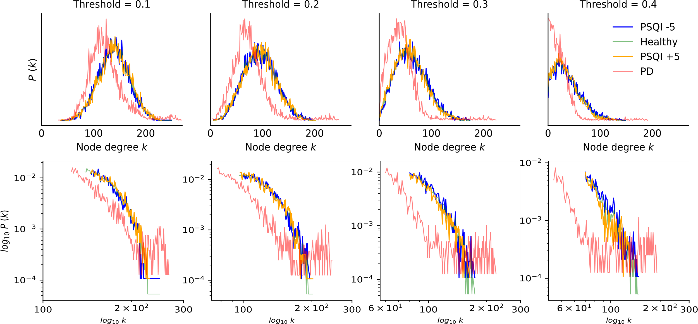

**Supplementary Figure 1. Node degree distributions for different thresholds.** Full distributions (top row) and its corresponding tails in log-log scale (bottom row) for the 4 different clinical groups. All four groups exhibited a power-law decay for highly connected nodes. This behavior exaggerated for larger thresholds, where the resemblance between the PD and PSQI+5 groups reached its maximum (bottom right). Probability distributions were computed by counting the number of times a unique node agree existed in the network, as opposed to the distributions in the main text that were obtained by estimating a probability density distribution for visualization purposes (i.e., smoother curves).

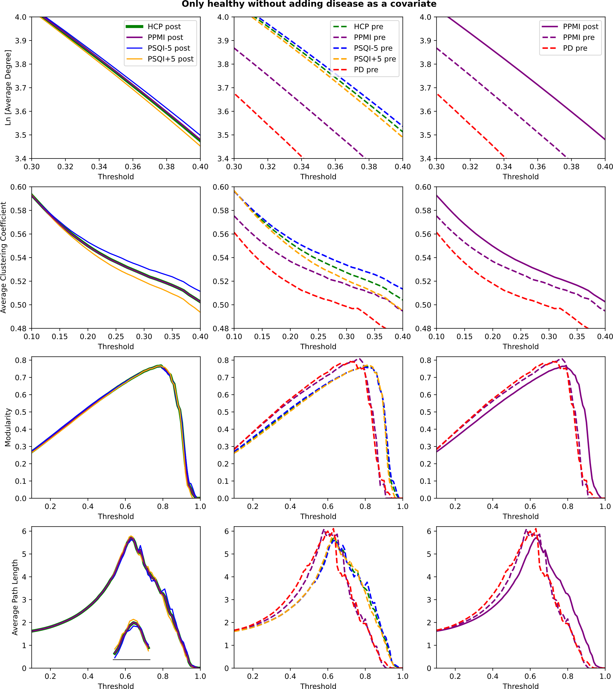

**Supplementary Figure 2. Results of the NeuroCombat harmonization when considering only healthy subjects from both datasets.** The two groups became equivalent after the procedure (as expected, left column). In the middle column, we show the values for each threshold prior to harmonization. Finally, in the right column, we show how the PPMI control group shifted along the direction indicated by $γ^{*}$ (see Fig. 5 in the main text) but kept the same shape. As a result, the metrics from the PD group should be conceptually shifted in the same way thus moving closer to the PSQI+5 group.

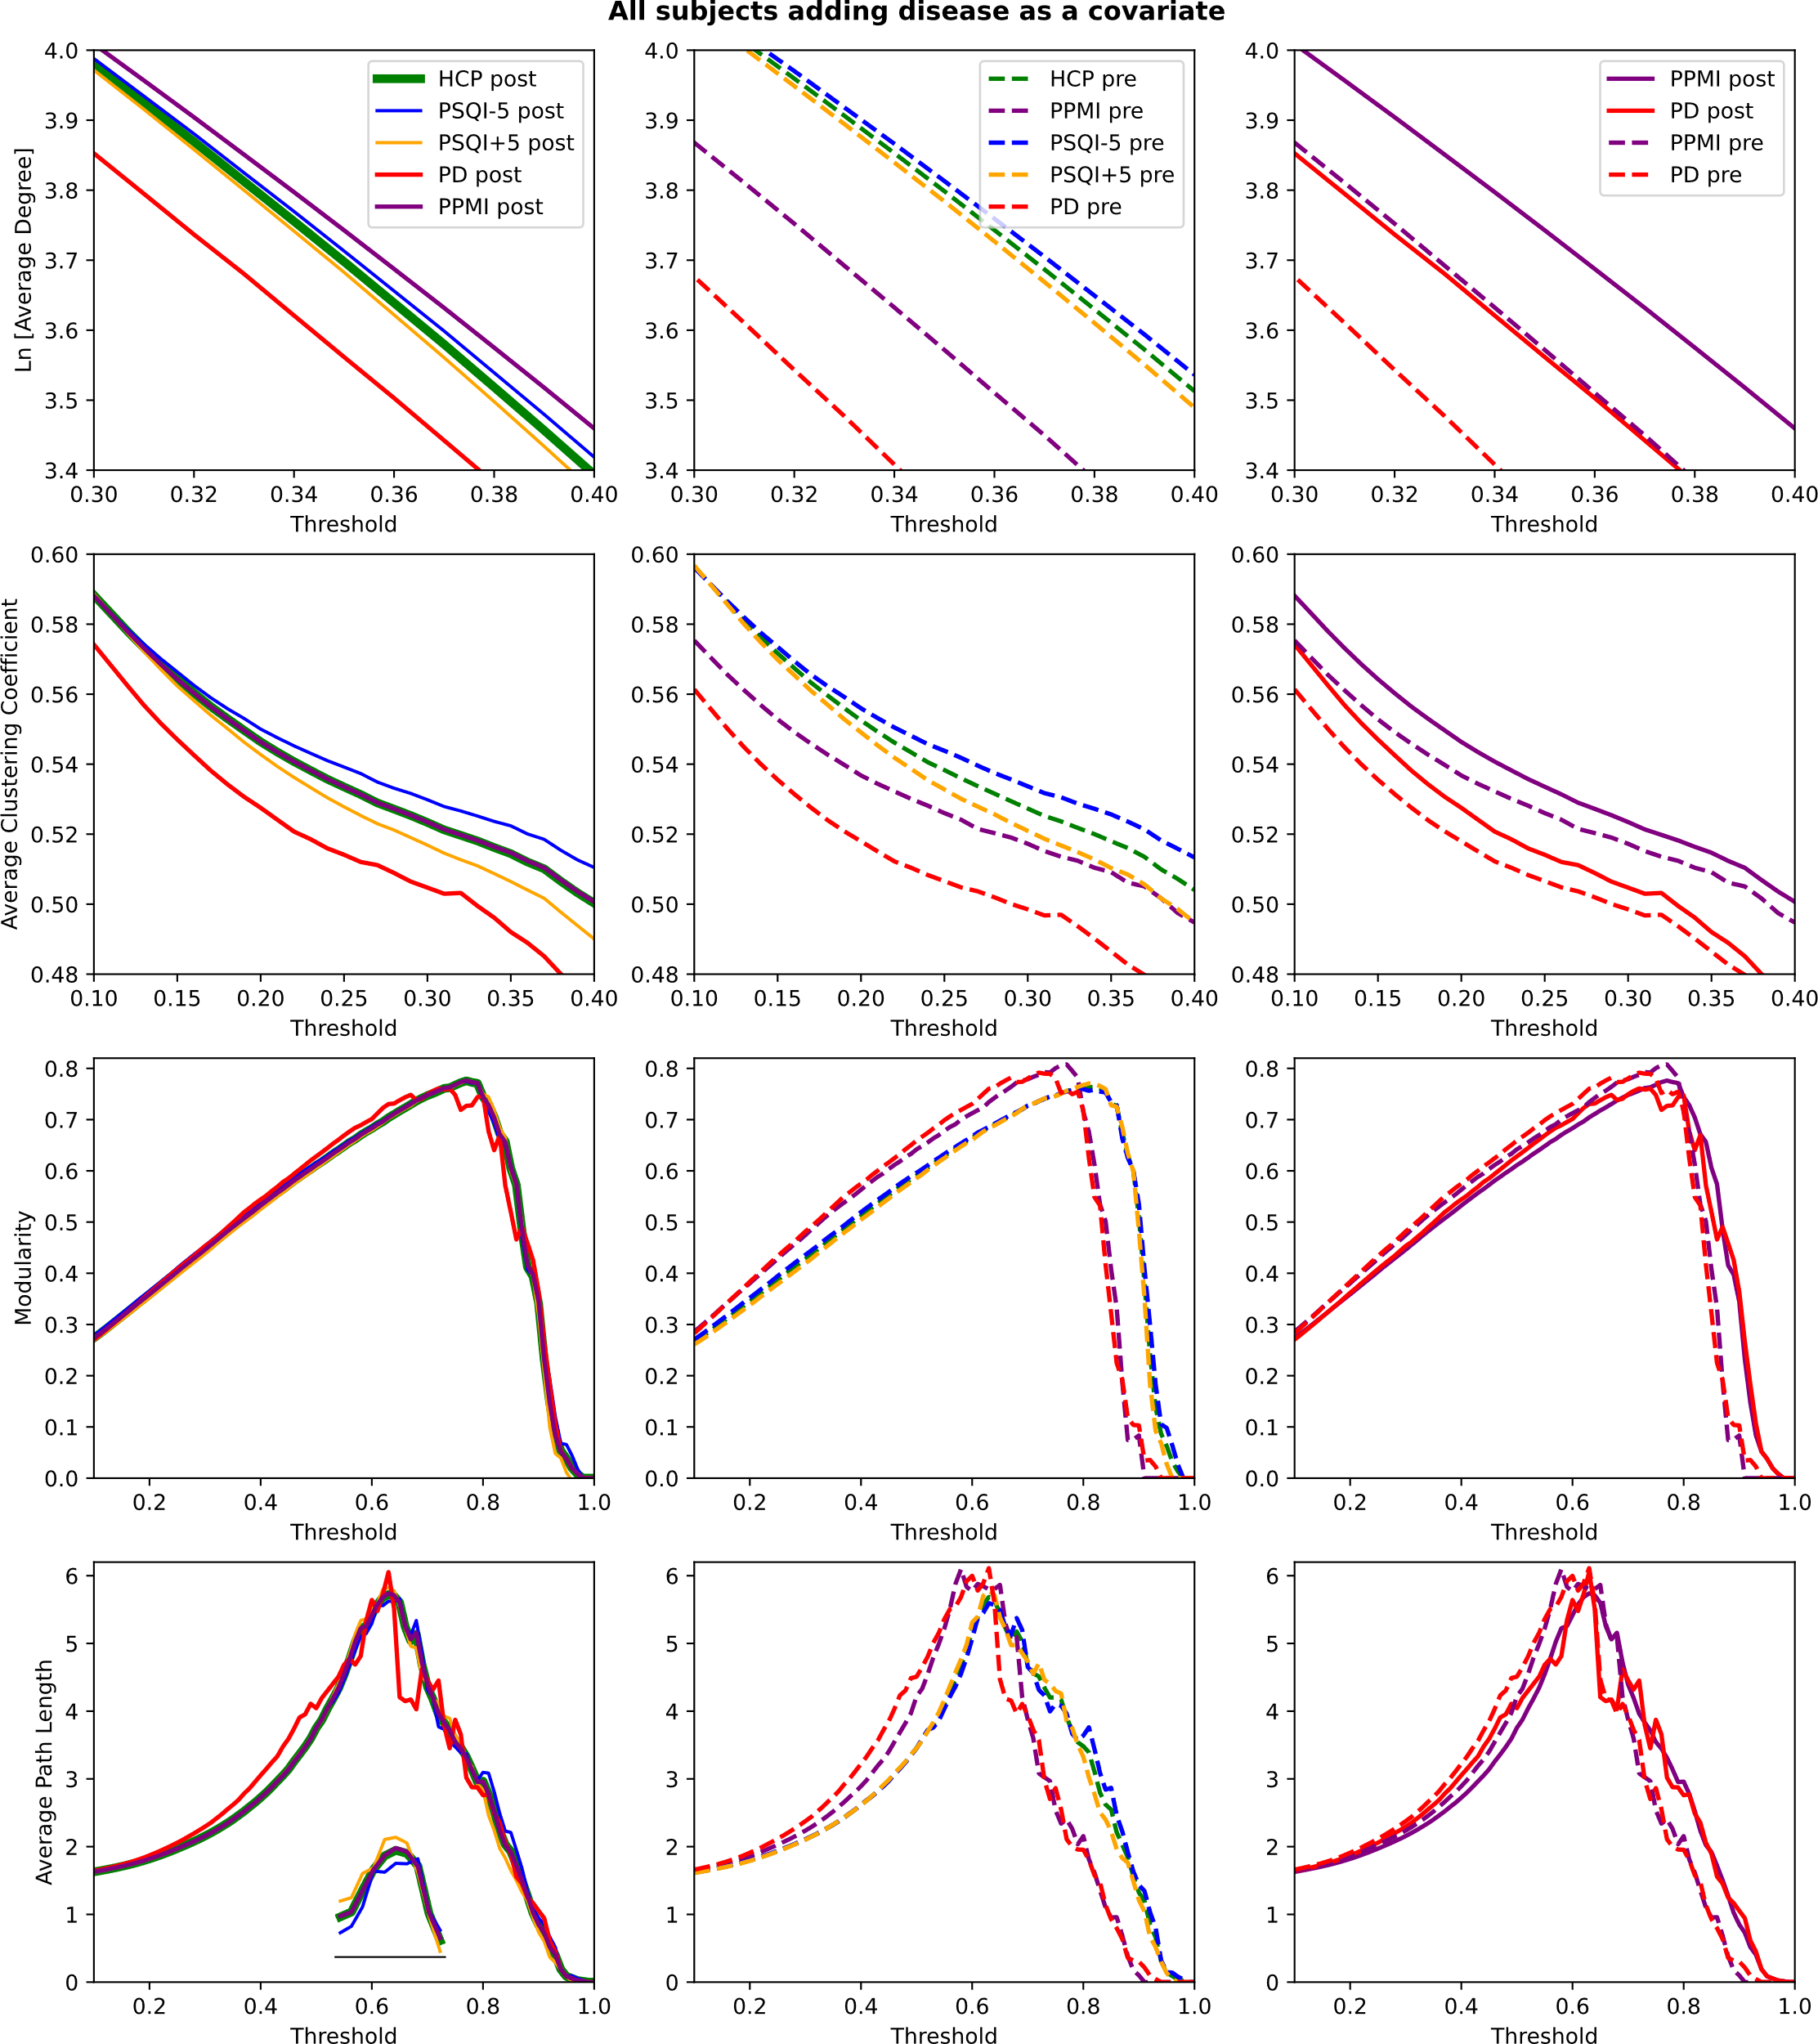

**Supplementary Figure 3. Results of the NeuroCombat harmonization when considering all subjects from both datasets.** For each threshold, the metrics after (left column) and before (middle column) applying the data harmonization procedure. The right column displays only results from the PPMI group before and after harmonization. The results are conceptually equivalent as the ones obtained when the PD group was not included (Supplementary Figure 1).

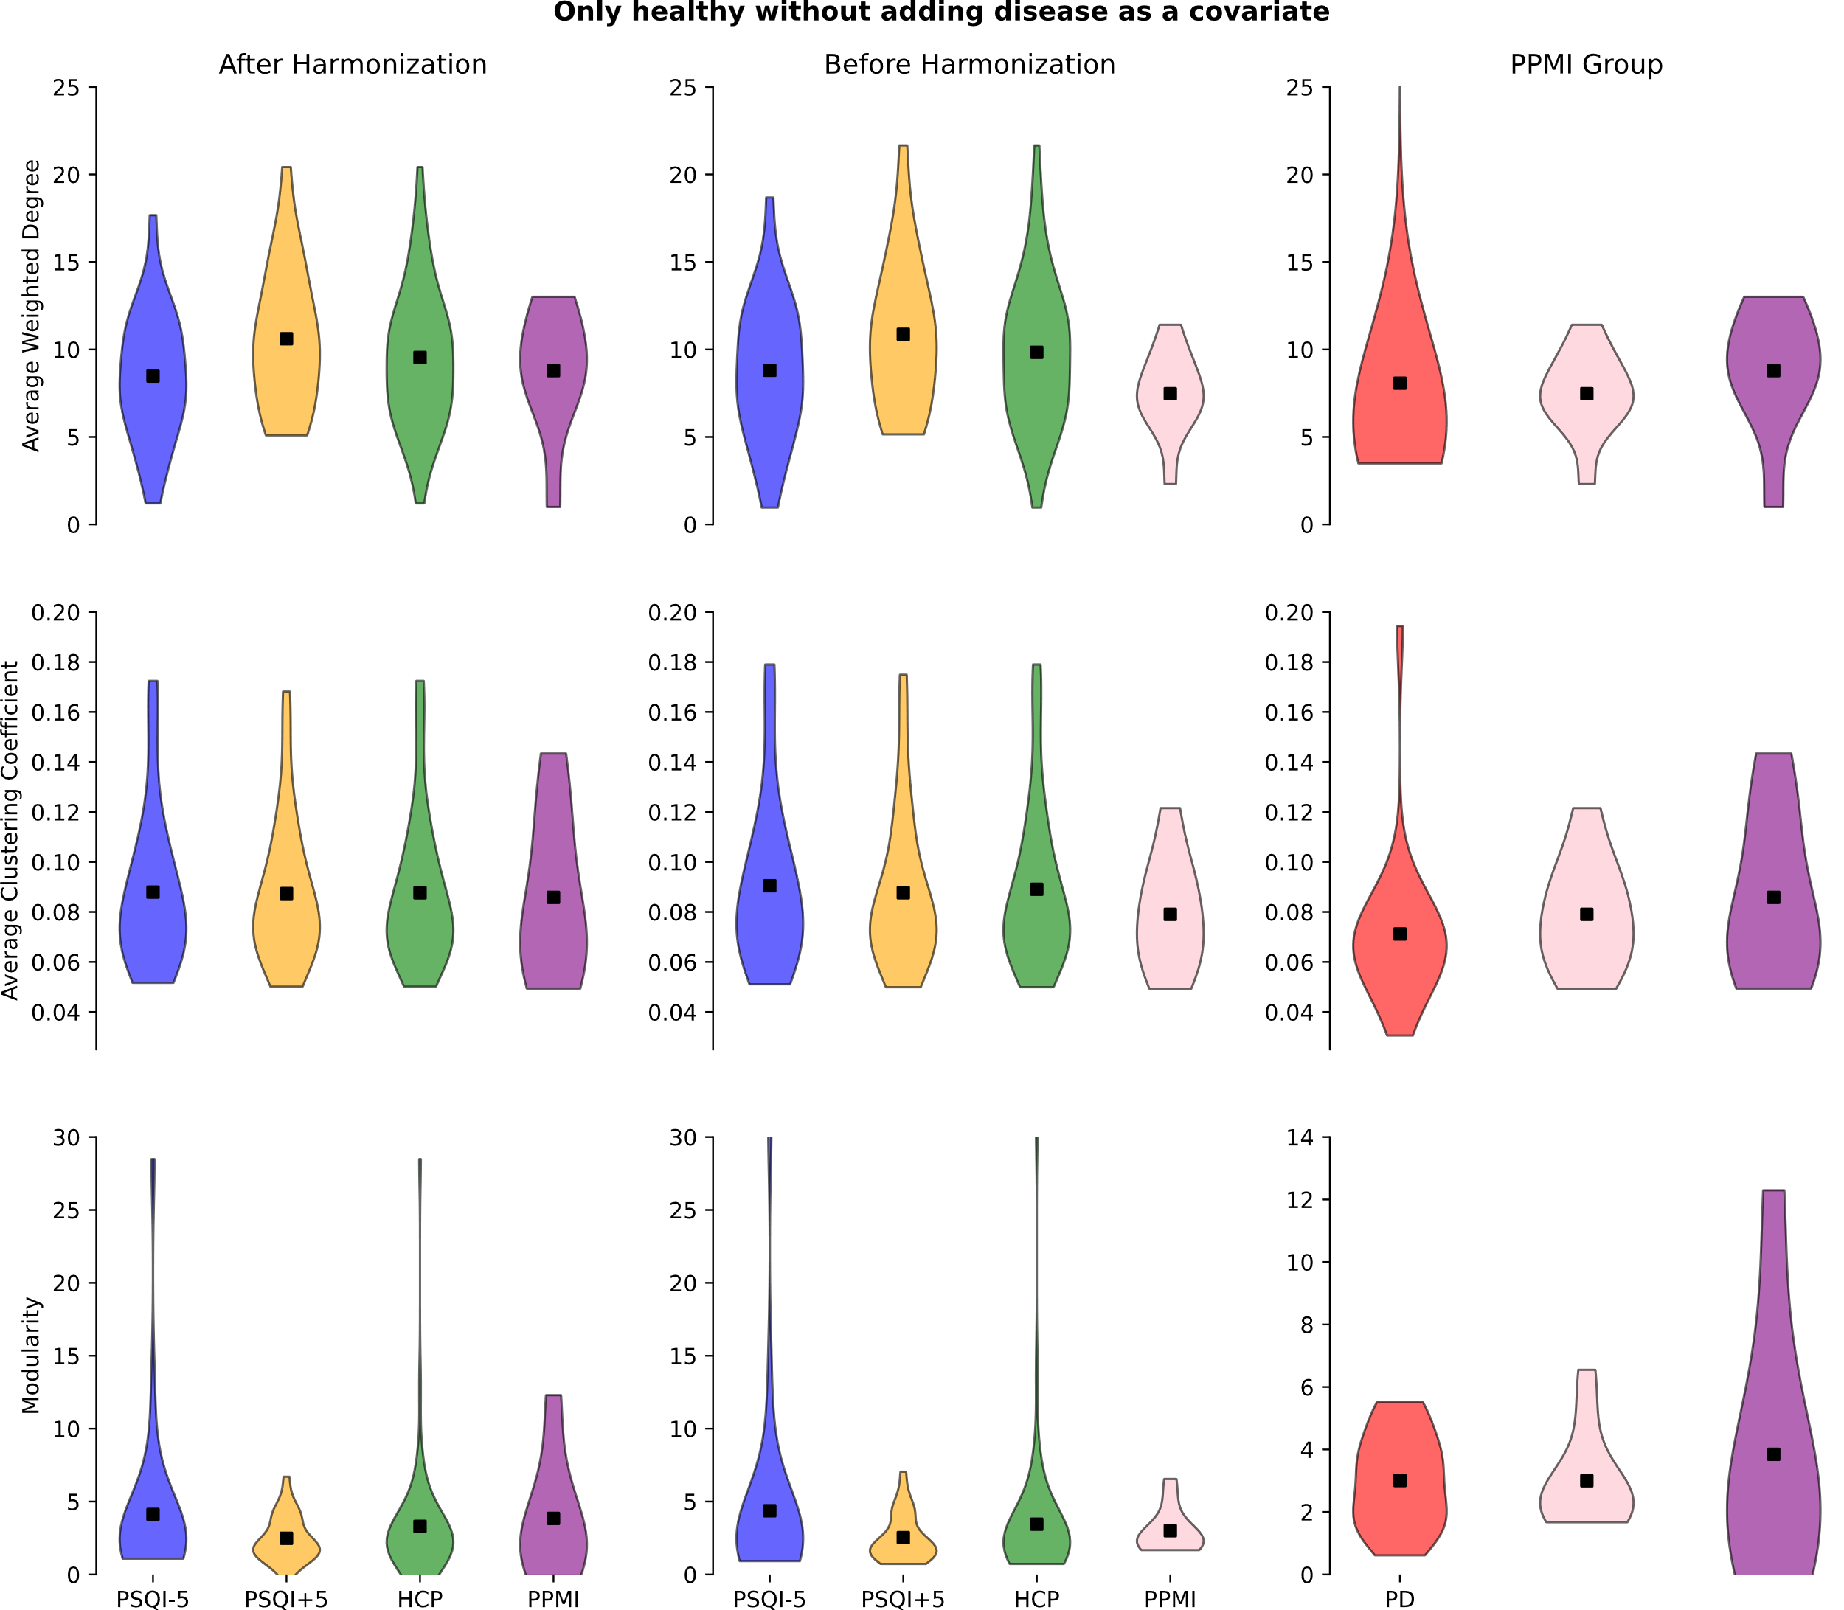

**Supplementary Figure 4. Graph metrics for the weighted and unthresholded networks after harmonizing with only healthy subjects.** Graph metrics of the weighted networks did not display any of the differences outlined in the main text. Thus, pathological effects are not immediately encoded in the functional networks but hidden in different geometrical scales (i.e., at different thresholds). Pink and purple groups refer to the healthy subjects from the PPMI site before and after harmonization.

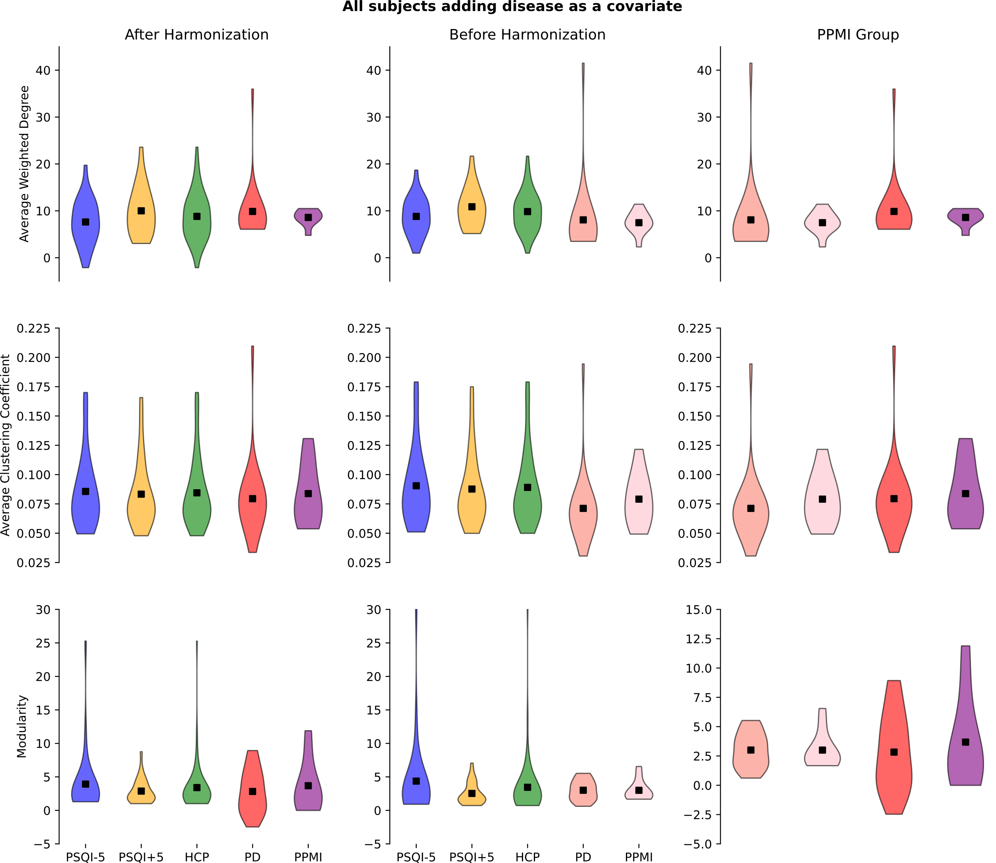

**Supplementary Figure 5. Graph metrics for the weighted and unthresholded networks after harmonizing with the relabeling trick.** Graph metrics of the weighted networks did not display any of the differences outlined in the main text. Thus, pathological effects are not immediately encoded in the functional networks but hidden in different geometrical scales (i.e., at different thresholds). Pink and purple groups refer to the healthy subjects from the PPMI site before and after harmonization.

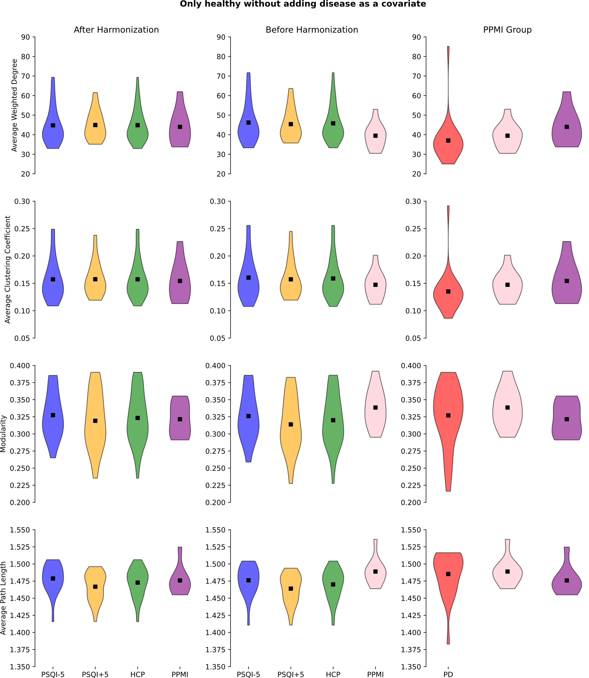

**Supplementary Figure 6. Graph metrics for the weighted and thresholded networks after harmonizing with only healthy subjects.** Graph metrics of the weighted networks after thresholding them (threshold=0.2) did not display any of the differences outlined in the main text. Thus, pathological effects are not immediately encoded in the functional networks but hidden in different geometrical scales (i.e., at different thresholds). Pink and purple groups refer to the healthy subjects from the PPMI site before and after harmonization.

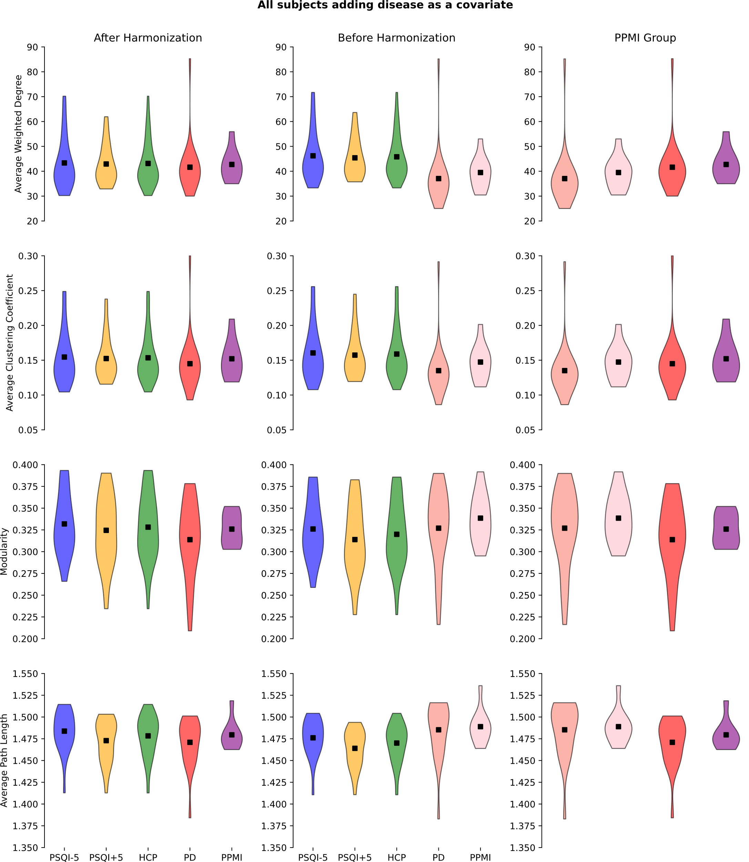

**Supplementary Figure 7. Graph metrics for the weighted and thresholded networks after harmonizing with the relabeling trick.** Graph metrics of the weighted networks after thresholding them (threshold=0.2) did not display any of the differences outlined in the main text. Thus, pathological effects are not immediately encoded in the functional networks but hidden in different geometrical scales (i.e., at different thresholds). Pink and purple groups refer to the healthy subjects from the PPMI site before and after harmonization.

**Supplementary Figure 8. Harmonization affects every subject after taking the absolute value of the matrices in the same manner.** For the weighted degree and clustering coefficient, the shift follows the same one shown previously.